19 - Talking Heads – Psycho Killer
Original: A Us: same
KORG:SFX, YAM organ0 & WURLI (not until bridge)

[Intro] A | A G | A | A G [7x]
Add SFX

[Verse] same as Intro [2x]

[Chorus]
F | G | A | A | F | G | C | C [2x]
F | G (to BRIDGE 2nd x, switch WURLI)

[Bridge] Surprise WURLI contrast
bm | bm | G | G [2x]
A | A | G | G | A | A | A | A
Switch: organ0

Last x of chorus:
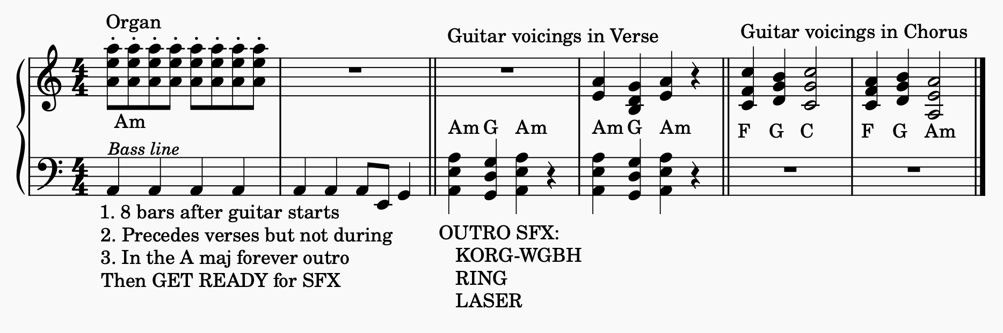
F | G | A | A | A keep playing A until end

